This is not a species distribution model

David Borchers et al

(“< >” is a placeholder for text to be completed)

Introduction

<Bumf about how people have misinterpreted estimated distributions of activity centres as density surfaces, with some citations.>

Estimated activity centre distributions and density surfaces

<Mathematical detail of estimated activity centre distributions (Bayesian and frequentist).>

<Mathematical detail of density surface (as intensity parameter of spatial point process).>

Simulation setup

<We illustrate by simulation.>

Estimated density surfaces and activity centre distributions are usually presented as image plots. This makes them easy for the reader to absorb and interpret. In order to present our argument and results in a way that is easy to interpret visually, we simulate data from a density surface model based on one of the most recognisable images in Western culture. This density surface is shown in Figure 1.

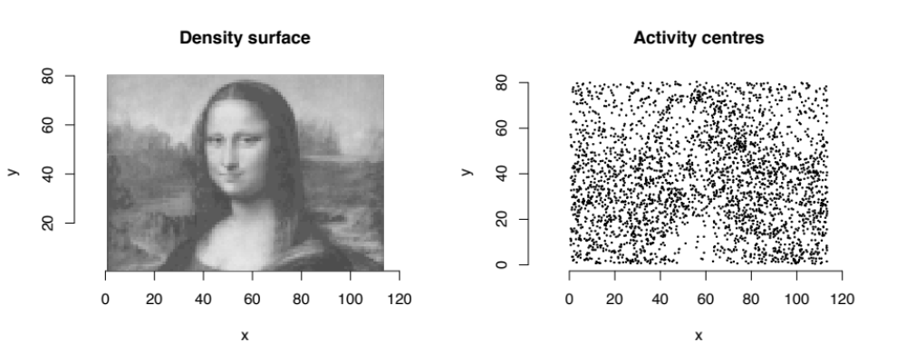

Figure 1: Density surface map (left: dark is high density, light is low density) and the associated simulated population of 2,980 activity centres (right).

We conducted three simulated surveys of the population, using a 7x7 array of detectors with three different array centres, as shown in Figure 2.
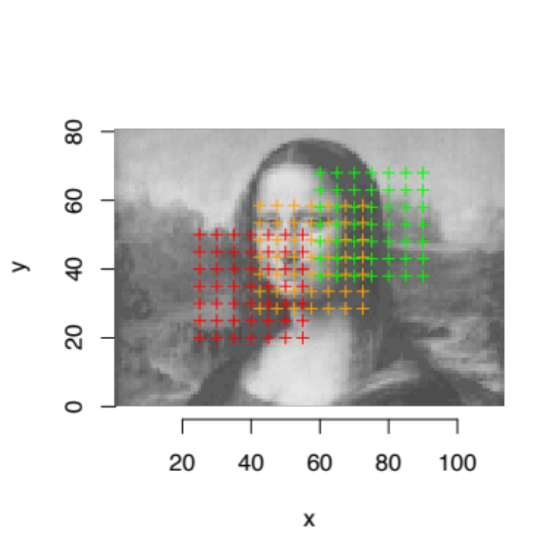
Figure 2: Detector arrays. Each array has a different colour.

<Detail on g0, sigma, array spacing, number occasions. Maybe plot of detection function.>

<Summary of sample sizes, etc.>

Estimated activity centre surface from model with constant density

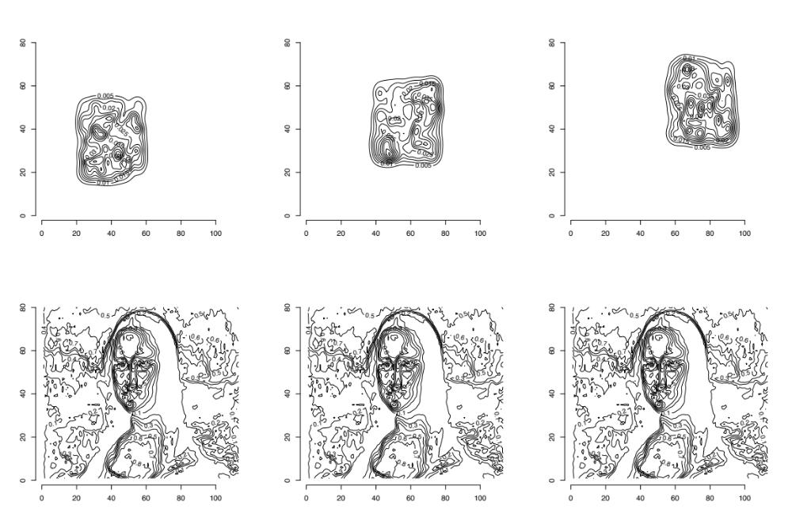
Figure 3: Estimated activity centre surface contours for each array (top row) with the Density surface contours in the bottom row.

<Message: (1) There is no resemblance at all between estimated activity centre contours and density contours! (2) The former ALWAYS has flat density away from the array. (3) The former also ALWAYS has outer contours that reflect the fall in detection probability as you move away from the array, which broadly follows the shape of the array, NOT the shape of the density surface.>

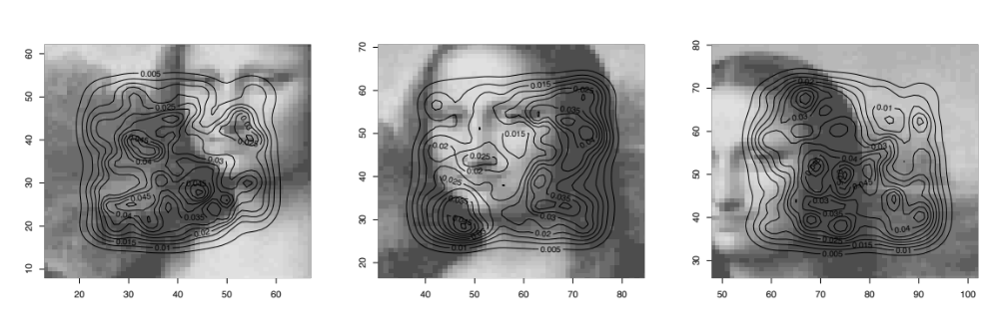
Figure 3: Estimated activity centre surface contours for each array, in the immediate vicinity of the array, overlaid on the true density surface.

<Message: (1) In the inside of the array, the estimated activity centre surface contours do manage to capture some broad features of the density surface, but this is very array-dependent. (Need an example with an array with greater spaceing, in which case the contours inside will reflect the detection function more, and will be shaped around the traps (I expect).>

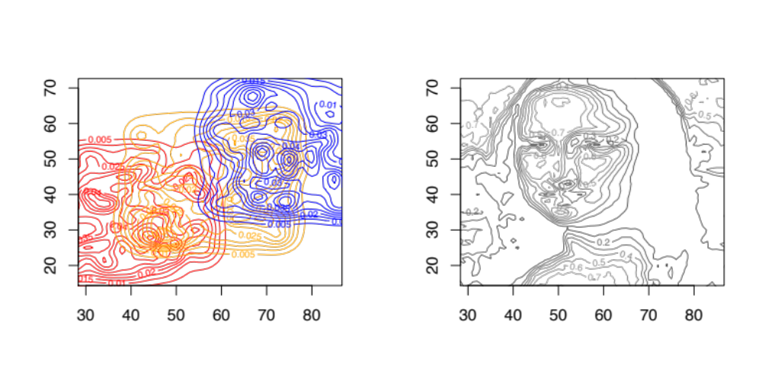
Figure 2: Estimated activity centre surface contours for each array in their area of overlap (left plot). The true density surface contours are shown in the right plot

<Message: Estimated activity centre surface is ARRAY-dependent. Move the array and you get a totally different surface, even in the regions in which the 3 arrays used here overlap.>

…

